# Memorandum

|  |  |
| --- | --- |
| To | Kate Ryan, Executive General Manager – WA & Strategy |
| Approved by (Group Manager): | Dean Sharafi |
| Approved by (Manager): | Toby Price |
| Prepared by: | Toby Price |
| Date: | 7/12/2022 |
| Title | **NCESS for Reliability 2024-25** |

## Purpose

AEMO has prepared a submission to the Coordinator of Energy (Coordinator) to determine whether or not to trigger a Non-Co-optimised Essential System Service (NCESS) procurement process.

This submission has been prepared as a consequence of identifying risks to AEMO’s ability to manage the system under forecast peak and minimum demand levels.

Clause 3.11A.2A of the Wholesale Electricity Market Rules (WEM Rules) requires AEMO to develop this submission to request the Coordinator to determine whether or not to trigger an NCESS procurement process.

The trigger submission includes sufficient information and analysis to allow the Coordinator to consider the factors outlined in clause 3.11A.7 of the WEM Rules.

## Recommendation

That the EGM for WA & Strategy approve this submission to the Coordinator.

## Background

System Design & Transformation has been undertaking analysis of fleet sufficiency in the 2024-25 Capacity Year to explore the risks to Power System Security and Reliability (PSSR) associated with the energy transition. Shortfalls of capacity are already impacting AEMO’s ability to manage the system in 2022-23 Capacity Year, due to, for peak demand:

* Increasing levels of Facility Forced outages
* Fuel risks (both Gas and Coal) which is increasingly requiring AEMO to negotiate fuel limited operations of baseload plant (for example stockpiling ahead of summer)
* Delays to the commissioning of new entrants to the 2022-23 Capacity Year

Similar challenges are being experienced in operating under minimum demand conditions, due to:

* Increasing penetration of Distributed Solar PV reducing operational demand
* Inability to maintain sufficient Ancillary Services to ensure PSSR under minimum operational demand

AEMO has undertaken future looking assessments of sufficiency by, for peak demand:

* Projecting requirements of the system (including changes to the Planning Criterion being contemplated under the Coordinators review of the RCM)
* Impacts of the Network Access Quantity Framework
* Known and likely entrants, retirements and changes to Capacity Credits assigned to the fleet
* Assumptions around the risk of persisting fuel limitations, represented by the largest coal unit and second largest gas unit (single fuel).

And for minimum demand:

* Forecast minimum demand (WEM 2022 ESOO)
* Minimum Demand Thresholds for 2024, based on current operational needs and forecast impacts of known storage facilities in the WEM.

Detailed overviews of the input assumptions are included in the submission.

## Issues and risks

* Whilst not obliged under the WEM Rules to consult with Western Power on this NCESS trigger request, AEMO has not formally consulted with Western Power. AEMO has notified Western Power of our intentions and provided detail of the input assumptions informally. The only reference to Western Power engagement is a statement relating to new entrants being informed by *“Based on feedback from Western Power and responses to AEMO’s Expression of Interest for the 2022 Capacity Cycle”,* noting this feedback was made some time ago and not formally in relation to this trigger submission.
* There are risks that the 2023 WEM ESOO may identify a larger RCR than used in this analysis (based on WEM 2022 ESOO), however this is the most up to date public forecast from AEMO available.
* There are risks that the fuel supply risks which form the majority of the shortfall for the peak capacity requirement do not eventuate, with a reputational risk to AEMO.
* We have assumed a linear fit of historical Capacity Credits to project the Intermittent Facility Capacity Credits for 2024 (per Facility for wind, as a fleet for Solar PV), this may not align with the CRC in the 2022 Capacity Cycle but should be more accurate than assuming current Capacity Credits are maintained in future years, given the historical trend.
* The procurement for NCESS will exclude Capacity that enters in the 2022 Reserve Capacity Cycle, whilst this would require participants make assumptions around the likelihood of being awarded an NCESS, there is a risk that participants withhold capacity to attain more favourable rates than available through the Reserve Capacity Mechanism and to maximise shortfalls (if any) identified in the 2022 Reserve Capacity Cycle.
* Techno-economic modelling undertaken by Robinson Bowmaker Paul (RBP) has supported the quantification of the minimum demand service and likely activations of the service, however, peak demand modelling for reliability was not used in AEMO’s trigger – due to diverging assumptions following the finalisation of the techno-economic model:
  + Inclusion of NAQ constraints
  + Varying assumptions around coal and gas fleet availability
  + Varying assumptions around intermittent Facilities contribution.

AEMO has instead leveraged an assessment based on the Reserve Capacity Mechanism, using a range of assumptions to demonstrate capacity shortfalls against the Reserve Capacity Requirement. The shortfall in Reserve Capacity can be valued equivalently to other capacity products (Capacity Credits or payments under a Supplementary Reserve Capacity contract), this may not correlate with a measure of unserved energy (and the associated value of unserved energy, valued according to the Value of Customer Reliability) associated with RBP’s modelling.

## Consultation

* As identified in the Risks and Issues section, no formal external consultation has occurred. Informal consultation has been made with Energy Policy WA to manage expectations of this submission and ensure any determination to trigger an NCESS procurement process is made in a timely manner.

## Next steps

* If the Coordinator determines to trigger the NCESS procurement process, AEMO will need to:
  + Release an Expressions of Interest request to market, within 15 Business Days, supported by:
    - A draft NCESS Service Specification (currently in draft)
    - A NCESS submission form (currently in draft)
    - A newspaper advertisement and website notification.

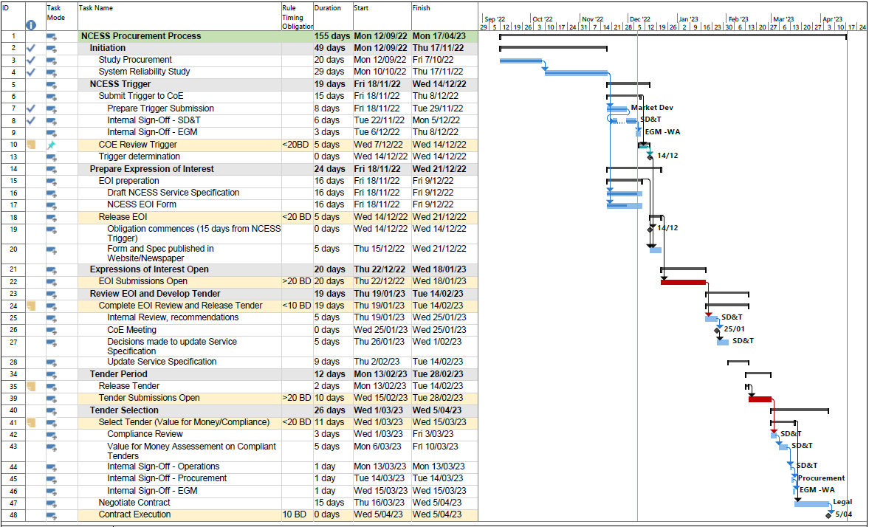

1. Gannt Chart for NCESS Procurement Process as at 7/12/22.

## Attachments

1. [221206-NCESS Trigger Submission-Reliability-Clean for EGM Sign.docx](https://aemocloud.sharepoint.com/:w:/s/WAFutureSystemDesign/EaakcmEfRF1Ohn7mNU-RFbUBES4LEr1QQBaG2S0p304s6Q?e=dE6d5Q)
2. [Gantt Chart](https://aemocloud.sharepoint.com/:b:/s/WAFutureSystemDesign/Eefhr-_EYMVLgifFjeXng7QBDxsS59pEISKy0cRoXeqVgA?e=ibGKKh)

## Approval



**Kate Ryan**

EGM WA and Strategy